

P.P.G. MEETING

Date: Tuesday 22nd October 2019
@ 11.00am
Location: GP Suite Cannock Chase Hospital.

Minutes

1) Persons Present: | Pam Burlingham, Margaret Price, Janice Lloyd, Sam Rasib
2) Apologies: | Janice welcomed everyone to the meeting and commenced with apologies from David Stagg, Susan Andrews, Betty Chapman and Sarah Giles
3) Minutes of previous meeting held 18th June 2019: | Minutes of meeting agreed as correct and passed.
4. Matters Arising: | None
5) Managers Report: | Revisit actions from previous year’s action plan for Survey results.  SR revisited actions set on the action plan and highlighted the main issues being the availability of appointments and getting through on the phone from the feedback provided last year. One of the actions agreed was to push for more patients to sign up for patient access. SR confirmed that the practice had been pushing this and was pleased to share that there has been an increase in numbers from 17% in December 18 to 24% in September 19.  SR confirmed that there still isn’t any further development in talks with the hospital with regards to introducing a new phone system.  SR had also looked at feedback from Friends & family surveys specifically for getting through on the phone and getting appointments. This feedback had been received through a text messaging service. SR also looked at appointment data specifically focusing on appointments available by the practice but not utilised/booked or DNA appointments. The collation of data was covering the period of 2nd January 2019 and 30th September 2019. The results were as follow:  Results:  Friends & Family Survey Feedback received regarding booking appointments and getting through on the phone  Total complaints about not being able to get through on the phone from January 19 and up to and including September 19 = 0  Total responses received about appointments from January 19 and up to and including September 19 = 79  Positive (no problems experienced with booking appointments) = 67  Negative (problems experienced with booking appointments) = 12  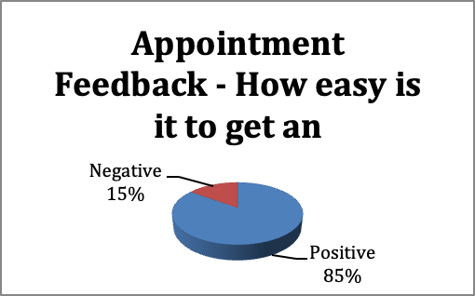  Appointments available by the practice but not utilised/booked or DNA  The practice and PPG members will continue to educate patients on patient access. Also patients to be educated on booking in with other clinicians within the practice where appropriate rather then booking with the GP to help free up more GP appointments for more complex matters/patients
  Total Available appointments but not booked | Total DNA’s
  547 | 408
  Total not booked & DNA’s | 955
6) Chairman, group items: | CCG District PPG: Held 10/10/19  Feedback was provided by MP which included some of the following points:  - Rachel Cuppitt having joined the Alliance to manage operational aspects and HR  - Visiting Speaker Dr Agrawal was present and spoke about the challenges being faced financially with delivering the anticoagulation service locally. However, Dr Free added that that the service will be delivered one way or another as from 31st October 2019  - Sandy Lane Lift  - Access to Mental Health Services  Date and time and venue of next District PPG meeting:  - Wednesday 6th November 2019  - 2pm to 4pm  - Council Chambers, South Staffordshire District Council, Wolverhampton road, Codsall, Wolverhampton, WV8 1PX  PPG Surveys:  Susan had recently highlighted an issue to SR about a patient being upset about how she were ‘being approached with a survey when being worried about something else’. Patient suggested that we put a sign up or got the receptionists to do it ‘more appropriately’. SR suggested that she was happy to get the reception team involved with handing out the surveys but asked if the PPG group members could still collate the results. This was agreed.  Follow up appointments:  It was mentioned how patients are going to desk after appointment with G.P. stating that they need a follow up appointment in 1 weeks time and being told to phone in on the morning. Janice made a suggestion that maybe it would be a good idea for the Doctor to provide the patient with a card stating the reason why the follow up appointment was necessary so that this can be handled appropriately rather then receptionist advising patients to call back on the morning.
7) Any other business: | None forwarded

Date of Next Meeting: 10th December @ 10am

